UK TRAIN SERVICES
EXECUTIVE PERFORMANCE REPORT

EXECUTIVE SUMMARY
This report evaluates 31,653 passenger journeys across UK train services between January and April 2026. The analysis combines service reliability, disruption causes, revenue, refund exposure, passenger demand, peak travel behaviour and route performance to identify the operational priorities with the greatest potential business impact.

31,653  Passenger journeys | £741,921  Gross revenue | 86.82%  On-time performance | £38,702  Refund exposure

Executive view

The network demonstrates a strong underlying level of service, with 86.82% of journeys recorded as on time. However, 13.18% experienced disruption through delays or cancellations. Weather is the largest individual contributor to delays, while the concentration of passenger volume on a small number of routes creates significant exposure to performance issues on high-demand corridors.
86.82%  On time | 7.24%  Delayed | 5.94%  Cancelled | 93.9%  Revenue retained

Five priorities for management
- Strengthen weather-readiness and contingency planning, given that weather accounts for 40.45% of delays.
- Prioritise reliability improvements on high-volume corridors where disruption affects a large passenger base.
- Reduce refund exposure by targeting delay management and passenger communication, since delays account for 67.6% of refund value.
- Use peak-hour demand data to improve capacity planning and resource deployment, particularly around the 8:00 AM peak.
- Investigate the improvement seen in April to identify operational practices that can be replicated across the network.

1. BUSINESS CONTEXT & ANALYTICAL SCOPE

1.1 Objectives
- Evaluate operational performance and identify service reliability patterns.
- Analyse revenue performance and financial exposure associated with disruption and refunds.
- Understand passenger behaviour, demand concentration and peak travel patterns.
- Identify routes and stations requiring operational attention.
- Translate analytical findings into practical management actions and measurable KPIs.

1.2 Data scope
Dimension | Scope
Analysis period | January – April 2026
Records analysed | 31,653 passenger journeys
Operational dimensions | Routes, stations, journey status, timestamps and disruption reasons
Commercial dimensions | Revenue, ticket type, railcard usage and refunds
Performance measures | On-time %, delays, cancellations and route reliability

1.3 Analytical approach
- SQL-based aggregation, time-series analysis and ranking.
- Categorical standardisation and validation of operational fields.
- Time parsing for AM/PM timestamps and hour-based demand analysis.
- Cross-dimensional analysis linking operational performance with revenue and customer impact.

2. DATA QUALITY & PREPARATION

2.1 Data quality challenges
- Inconsistent categorisation in disruption-reason fields, including variations in capitalisation and naming.
- 12-hour AM/PM time formats requiring parsing for hourly analysis.
- Journey duration and timestamp calculations requiring validation.
- Database/table qualification issues resolved through fully qualified table references.

2.2 Quality controls applied
- Standardised categorical values and station/reason naming conventions.
- Validated journey totals, revenue totals and journey-status distributions.
- Validated time calculations against sample records.
- Retained 100% of records following preparation and validation.

3. KEY PERFORMANCE FINDINGS

3.1 Passenger demand & usage
8,111  January journeys | 7,644  February | 8,117  March | 7,781  April

Passenger demand remained relatively stable across the four-month period. February recorded the lowest volume, while March produced the highest. The movement is consistent with normal calendar effects and indicates resilient underlying demand.
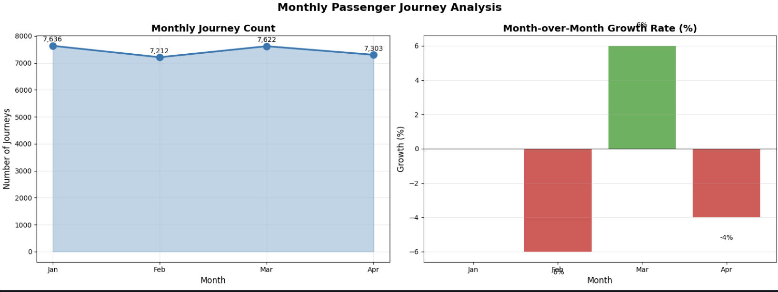

Railcard penetration
Railcard holders represent 66.5% of passengers, while non-railcard passengers represent 33.5%. This indicates that discount programmes are relevant to more than one-third of the customer base and should be considered when evaluating pricing, loyalty and revenue strategies.
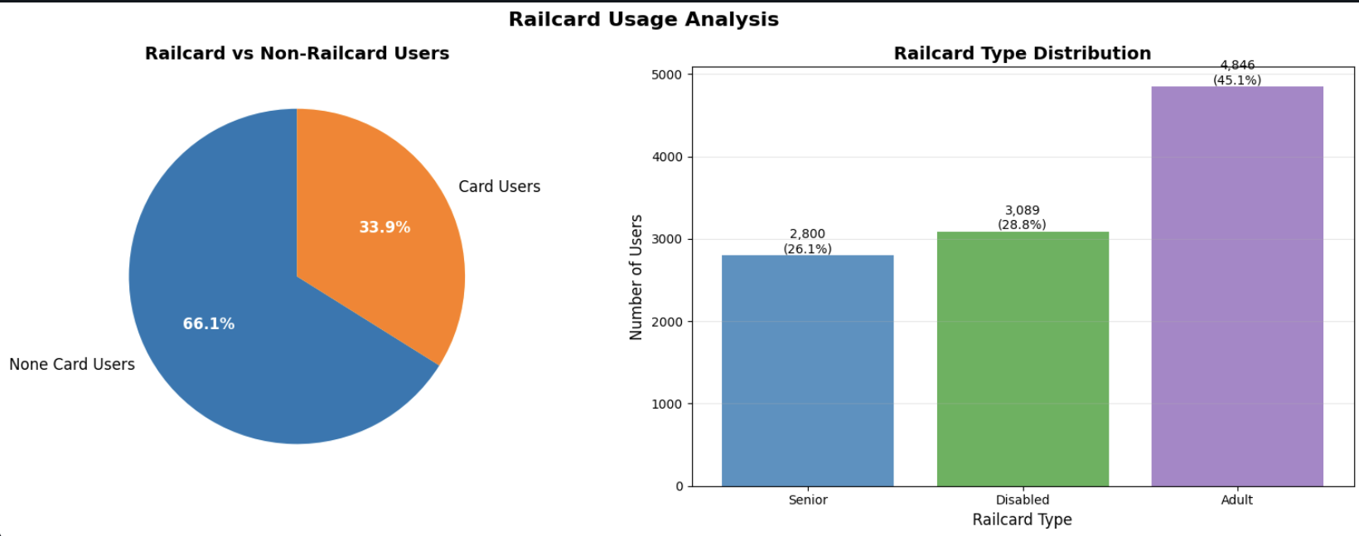

Peak travel
The 6:00–9:00 AM window is the key commuter period, with 8:00 AM identified as the busiest hour. The leading AM stations are Manchester Piccadilly, London Euston, Liverpool Lime Street, Birmingham New Street and London Kings Cross.
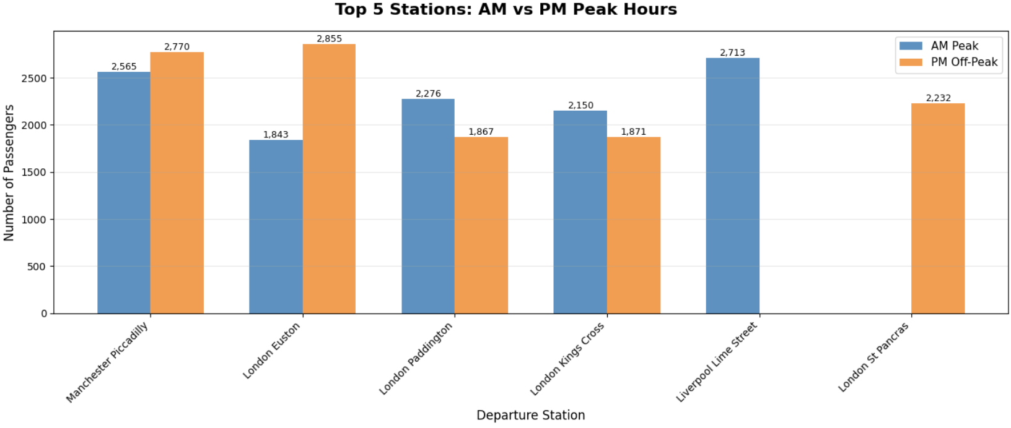

Ticket mix
- Advance tickets: £289,896 (39.1% of revenue)
- Off-Peak tickets: £241,614 (32.6%)
- Anytime tickets: £209,455 (28.3%)

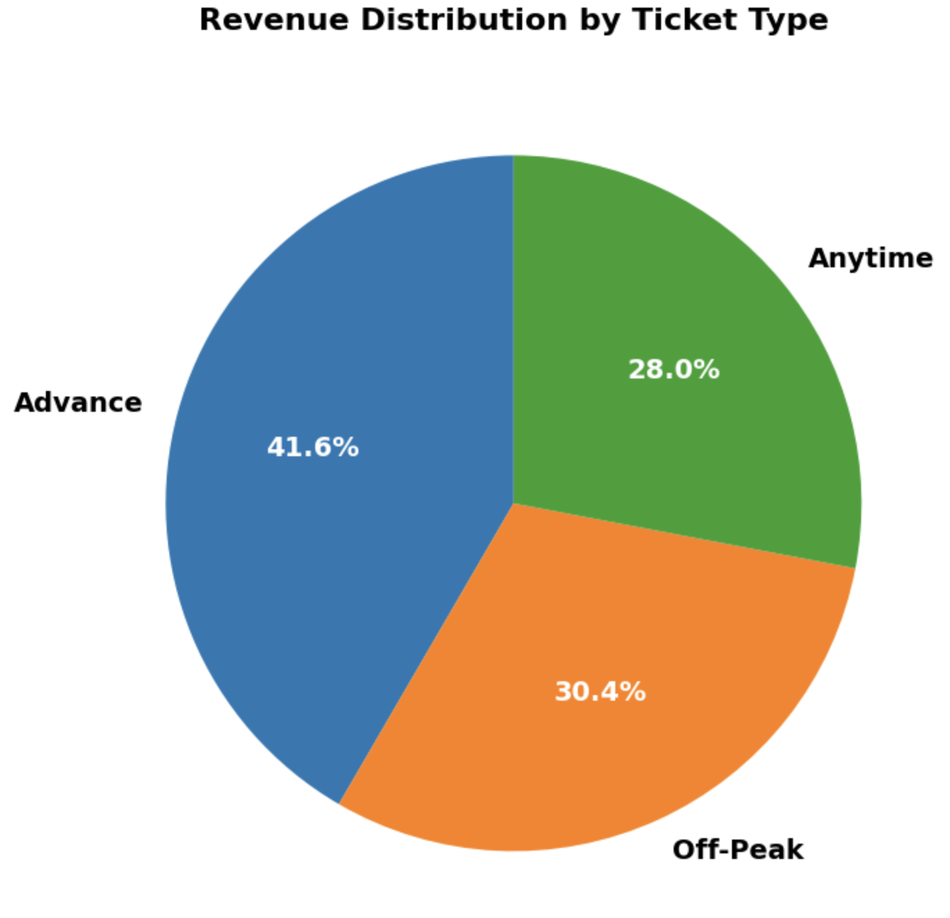

3.2 Service reliability
27,481  On time | 2,292  Delayed | 1,880  Cancelled | 13.18%  Total disruption

Overall reliability is positive but leaves a material opportunity for improvement. Approximately one in every eight journeys experienced either a delay or cancellation.

Delay root causes
Cause | Incidents | Share of delays
Weather conditions | 927 | 40.45%
Technical issues | 472 | 20.59%
Signal failure | 451 | 19.68%
Staff shortage | 355 | 15.49%
Traffic | 87 | 3.80%
Management implication: Weather is the single largest delay driver. Its 40.45% contribution makes weather-readiness the clearest operational priority, while technical, signalling and staffing issues remain important secondary contributors.

Cancellation profile
- Signal failure: 519 cancellations (27.6%)
- Staff shortage: 454 cancellations (24.2%)
- Weather conditions: 445 cancellations (23.7%)
- Technical issue: 235 cancellations (12.5%)
- Traffic: 227 cancellations (12.1%)

3.3 Revenue & refund exposure
£741,921  Gross revenue | £696,465  Net revenue | £45,456  Cancelled-service revenue | £38,702  Refund exposure

Revenue performance
- On-time services generated £569,651 (76.8% of gross revenue).
- Delayed services generated £126,814 (17.1%).
- Cancelled services resulted to lose of £45,456 (6.1%).
- Net revenue after cancellations was £696,465, representing 93.9% revenue retention.

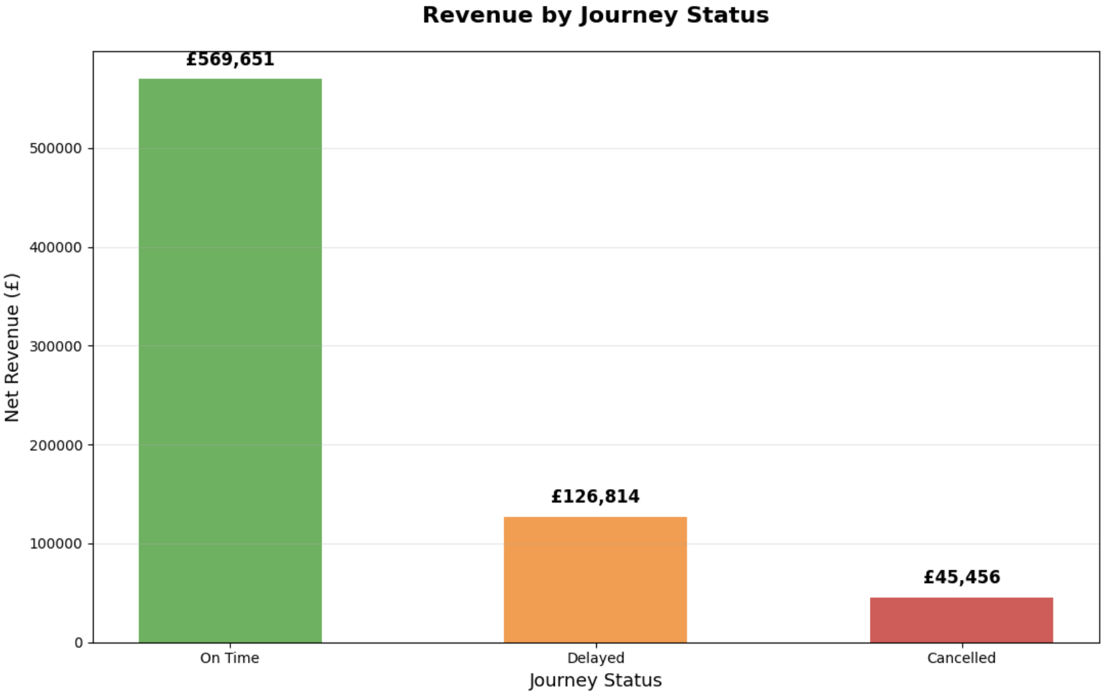

Monthly net revenue
- January: £185,422
- February: £151,116
- March: £184,933
- April: £174,994
Average monthly net revenue was approximately £174,116. January was the strongest month, while February was the weakest before revenue recovered strongly in March.
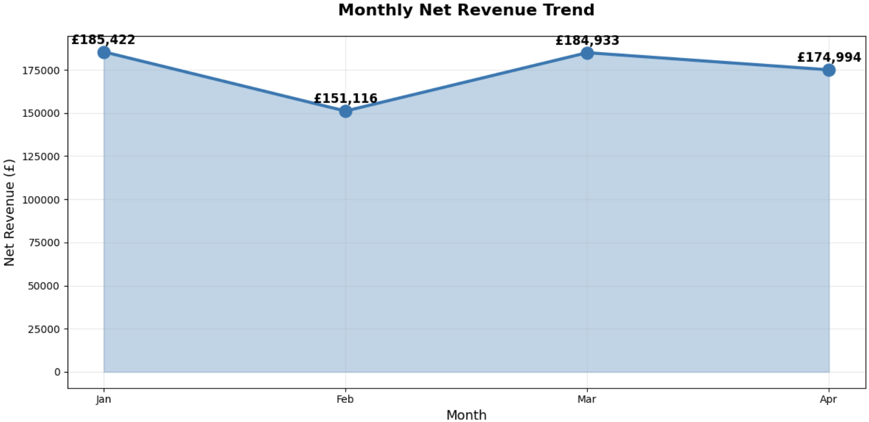

Refund exposure
Total refund exposure was £38,702 across 572 requests. Delayed journeys accounted for £26,165 (67.6%) of refund value, compared with £12,537 (32.4%) for cancellations. This indicates that reducing delays could have a meaningful financial benefit in addition to improving customer experience.
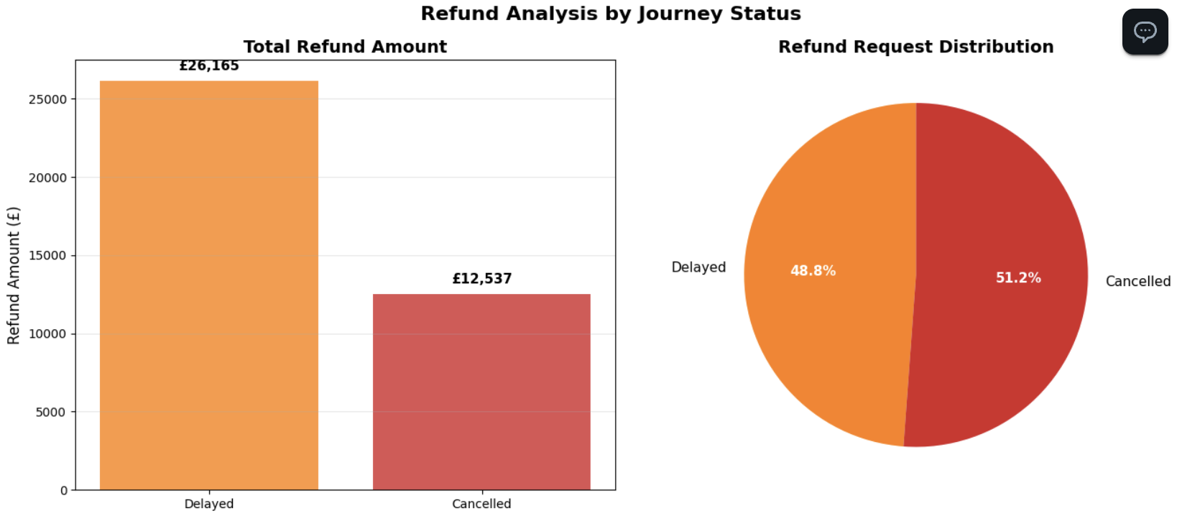

Highest refund-exposure stations
- Liverpool Lime Street: £14,587
- Manchester Piccadilly: £9,463
- London Euston: £2,778
- Birmingham New Street: £2,224
- London Paddington: £1,792

3.4 Route & network concentration
Passenger volume is highly concentrated. The five leading routes account for approximately 63.5% of all journeys, meaning performance on these corridors has an outsized effect on overall network experience.
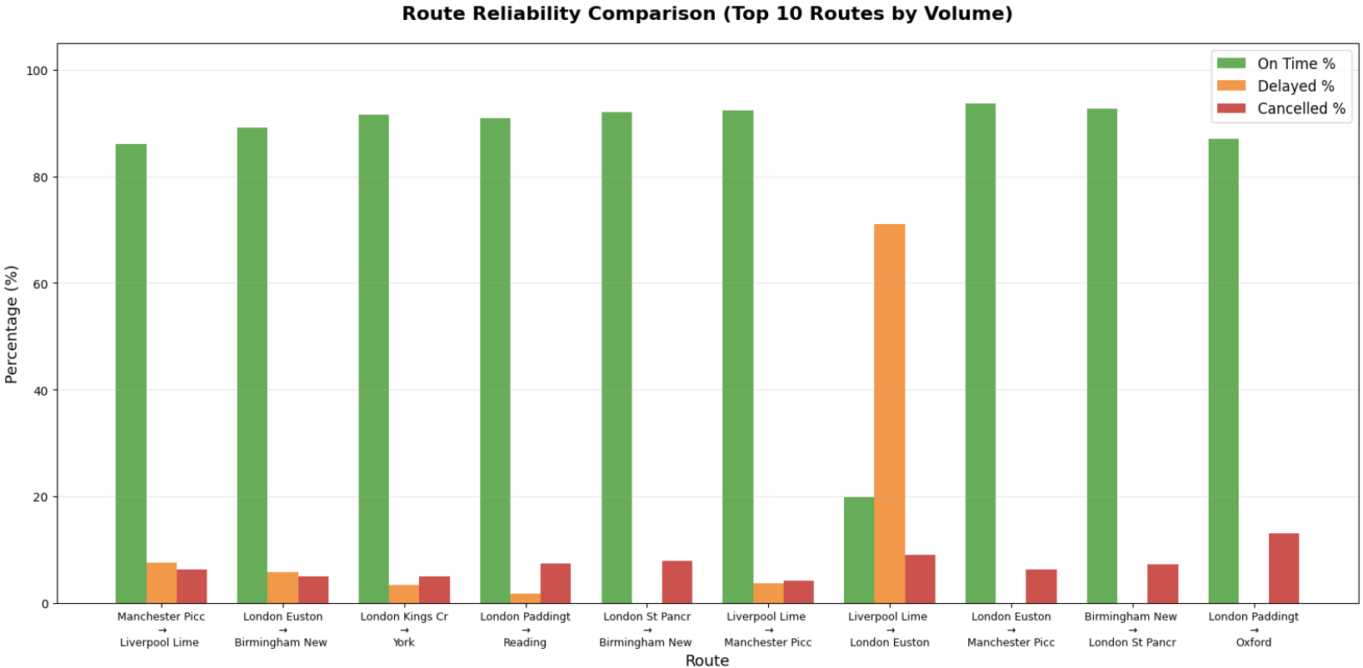
- Manchester Piccadilly → Liverpool Lime Street: 4,628 journeys
- London Euston → Birmingham New Street: 4,209
- London Kings Cross → York: 3,922
- London Paddington → Reading: 3,873
- London St Pancras → Birmingham New Street: 3,471

Priority reliability corridors
- London St Pancras → Birmingham: 273 cancellations (7.9% rate)
- London Paddington → Reading: 286 cancellations (7.4% rate)
- Manchester Piccadilly → Liverpool: 290 cancellations (6.3% rate)
- Liverpool Lime Street → London Euston: 780 delays — highest delay volume
- Manchester Piccadilly → Liverpool: 354 delays
- London Euston → Birmingham: 242 delays
Strategic implication: The combination of high passenger concentration and disruption on selected corridors means route-level interventions can potentially deliver disproportionate improvements in network performance.

4. STRATEGIC RECOMMENDATIONS

1. Build a weather resilience programme
Action: Develop route-specific weather contingency playbooks, pre-position operational resources and introduce proactive passenger communication.
Expected impact: Reduce the largest single contributor to delays and improve resilience during adverse conditions.
KPI: Weather-related delay incidents; delay rate during adverse weather; recovery time.

2. Prioritise high-volume disruption corridors
Action: Create a route-level performance programme focused initially on the highest-volume and highest-disruption corridors.
Expected impact: Improve passenger experience where operational changes can affect the largest customer population.
KPI: On-time performance by route; cancellation rate; passengers affected per disruption.

3. Reduce delay-driven refund exposure
Action: Review the operational causes behind delay-related refunds and strengthen disruption communication and recovery processes.
Expected impact: Protect revenue while improving customer satisfaction.
KPI: Refund value per 1,000 journeys; refund request rate; average refund cost.

4. Optimise peak-hour capacity and staffing
Action: Align staffing, platform resources and capacity planning with the 6:00–9:00 AM demand profile, especially the 8:00 AM peak.
Expected impact: Improve operational efficiency during the period of greatest passenger concentration.
KPI: Passengers per peak hour; staffing coverage; peak-period disruption rate.

5. Replicate April's improvement
Action: Conduct a structured review of operational changes, staffing, disruption causes and route performance in April.
Expected impact: Identify practices associated with the reduction in delays and standardise successful interventions.
KPI: Month-on-month delay rate; intervention effectiveness; repeatability of improvement.

6. Strengthen data governance
Action: Introduce controlled category definitions, validation rules and automated data-quality checks.
Expected impact: Improve reporting consistency and reduce analytical rework.
KPI: Data completeness; category exceptions; validation failure rate.

5. MANAGEMENT DASHBOARD
The following KPI framework is recommended for ongoing executive monitoring:
KPI | Current position | Management focus | Suggested cadence
On-time performance | 86.82% | Improve reliability | Weekly
Cancellation rate | 5.94% | Reduce avoidable cancellations | Weekly
Delay rate | 7.24% | Target root causes | Weekly
Refund exposure | £38,702 | Protect revenue | Monthly
Net revenue | £696,465 | Sustain revenue retention | Monthly
Peak-hour demand | 8:00 AM peak | Optimise resources | Weekly
Weather-related delays | 40.45% | Improve resilience | Monthly

6. CONCLUSION
The analysis indicates a network with strong baseline demand and relatively high on-time performance, but with material operational and financial exposure arising from disruption. The most significant opportunity is to move from reactive disruption management towards targeted, preventative operational planning.
Weather resilience, high-volume corridor performance, delay reduction, peak-hour resource planning and refund management should therefore form the core of the improvement agenda. At the same time, the apparent improvement in April provides an opportunity to identify and replicate practices that may already be delivering better performance.
Ultimately, the greatest value will come from linking operational KPIs to financial and customer outcomes. This creates a management framework in which reliability improvements are not treated solely as service metrics, but as drivers of revenue protection, customer experience and operational efficiency.

